June 3, 2021

The Honorable Chuck Schumer  Senator  322 Hart Senate Office Building  Washington, D.C. 20510 | The Honorable Mitch McConnell  Senator  317 Russell Senate Office Building  Washington, D.C. 20510

Dear Majority Leader Schumer and Republican Leader McConnell:

We urge you to reject President Biden’s nominees to lead U.S. Citizenship and Immigration Services (USCIS), U.S. Customs and Border Protection (CBP), and U.S. Immigration and Customs Enforcement (ICE).

Since taking office, President Joe Biden has unleashed the worst border crisis in two decades. He inherited a border that was more secure than it was four years ago and a set of policies that were effective in preventing illegal immigration. Yet President Biden repealed or modified those policies and created a border crisis. President Biden’s nominees either helped develop the policies that have produced the crisis or have shown an unwillingness to enforce immigration law. They will not enact the changes necessary to end the crisis.

In April, over 178,000 illegal aliens were apprehended at the border, representing a 944 percent increase from the prior year. April was not an anomaly; in March, more than 173,000 were apprehended, in February more than 101,000 were apprehended. The inhumane border crisis that the Biden administration’s policies created is growing.

The administration has reinstated catch and release policies. It is spending hundreds of millions of U.S. taxpayer dollars to transport and house illegal aliens in the interior of the United States. In some cases, aliens are released without a Notice to Appear. Pretending that illegal aliens will report to ICE offices to be placed into removal proceedings is sheer folly.

The crisis is happening because of a methodical undoing of successful border security and immigration policies. The Biden administration stopped construction of the border wall, ended the successful Migrant Protection Protocols, attempted to halt all deportations, promised the largest amnesty in American history, and declared the United States a sanctuary country by limiting enforcement of our immigration laws.

You are now being asked to consider the nominations of key personnel at the Department of Homeland Security (DHS). President Biden has nominated Ur Jaddou to serve as the Director of USCIS, Chris Magnus to serve as Commissioner of CBP, and Ed Gonzalez to serve as Assistant Secretary of Homeland Security (Director of ICE). All three of these nominations should be rejected.

Ur Jaddou led the Biden-Harris transition team’s review of DHS. In this role she developed the policies that created the current crisis at the southern border. Chris Magnus publicly defended sanctuary jurisdiction policies that encourage illegal immigration, make it more difficult for DHS to enforce immigration law, and endanger federal law enforcement officers.

While serving as Sheriff of Harris County, Texas, Ed Gonzalez terminated a formal cooperation agreement with ICE, the agency he is now nominated to lead. He prohibited his deputies from participating in immigration enforcement actions with federal partners including ICE.

The policies that these nominees promoted in their previous positions clearly demonstrate the nominees will be unwilling to make the decisions necessary to enforce the law and end the current border crisis. Confirming these nominees would endorse the policies that created the crisis. We respectfully request that you reject these nominees in favor of individuals dedicated to protecting our national security, sovereignty, and well-being.

Sincerely,
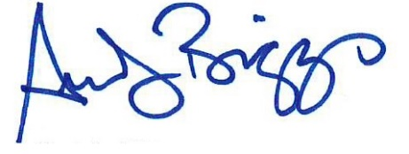 | 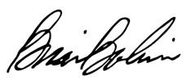
Andy Biggs  Member of Congress  Co-Chair, Border Security Caucus | Brian Babin, D.D.S.  Member of Congress  Co-Chair, Border Security Caucus
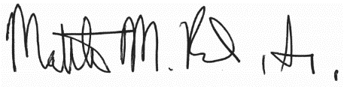 | 
Matthew Rosendale, Sr.  Member of Congress | Ted Budd  Member of Congress
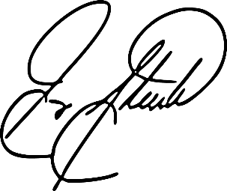 | 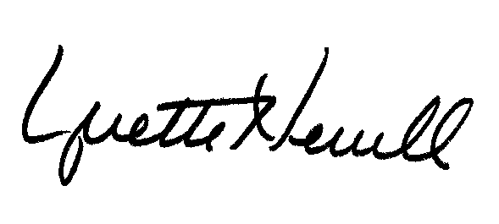
W. Gregory Steube  Member of Congress | Yvette Herrell  Member of Congress
 | 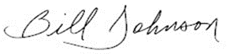
Diana Harshbarger  Member of Congress | Bill Johnson  Member of Congress
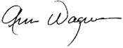 | 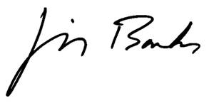
Ann Wagner  Member of Congress | Jim Banks  Member of Congress
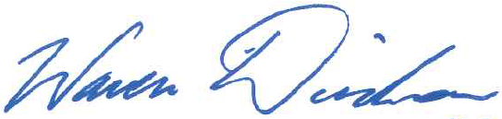 | 
Warren Davidson  Member of Congress | Glenn Grothman  Member of Congress
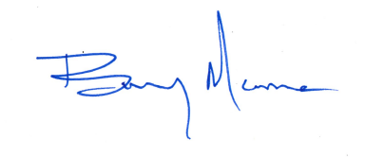 | 
Barry Moore  Member of Congress | Jody Hice  Member of Congress
 | 
Mo Brooks  Member of Congress | John Joyce  Member of Congress
 | 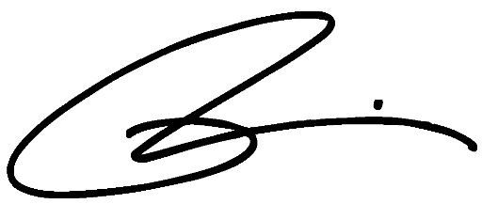
Lauren Boebert  Member of Congress | Brian Mast  Member of Congress
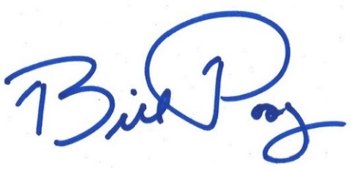 | 
Bill Posey  Member of Congress | Marjorie Taylor Greene  Member of Congress
 | 
Randy K. Weber  Member of Congress | Tom McClintock  Member of Congress
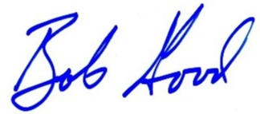 | 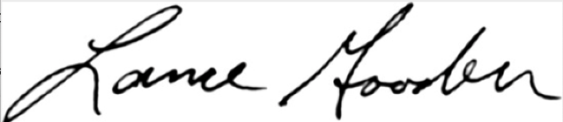
Bob Good  Member of Congress | Lance Gooden  Member of Congress
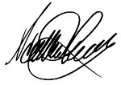 | 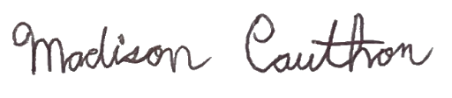
Scott Perry  Member of Congress | Madison Cawthorn  Member of Congress
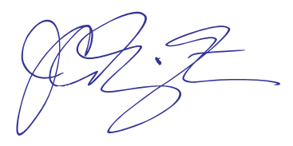 | 
Jodey C. Arrington  Member of Congress | Mike Rogers  Member of Congress
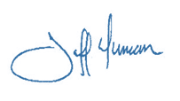 | 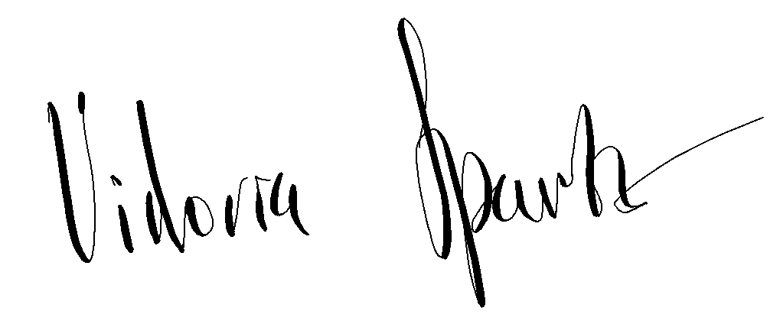
Jeff Duncan  Member of Congress | Victoria Spartz  Member of Congress

cc: The Honorable Tammy Baldwin
The Honorable John Barrasso
The Honorable Michael Bennet
The Honorable Marsha Blackburn
The Honorable Richard Blumenthal
The Honorable Roy Blunt
The Honorable Cory Booker
The Honorable John Boozman
The Honorable Mike Braun
The Honorable Sherrod Brown
The Honorable Richard Burr
The Honorable Maria Cantwell
The Honorable Shelley Moore Capito
The Honorable Benjamin Cardin
The Honorable Thomas Carper
The Honorable Robert Casey
The Honorable Bill Cassidy
The Honorable Susan Collins
The Honorable Christopher Coons
The Honorable John Cornyn
The Honorable Catherine Cortez Masto
The Honorable Tom Cotton
The Honorable Kevin Cramer
The Honorable Mike Crapo
The Honorable Ted Cruz
The Honorable Steve Daines
The Honorable Tammy Duckworth
The Honorable Richard Durbin
The Honorable Joni Ernst
The Honorable Dianne Feinstein
The Honorable Deb Fisher
The Honorable Kirsten Gillibrand
The Honorable Lindsey Graham
The Honorable Chuck Grassley
The Honorable Bill Hagerty
The Honorable Margaret Wood Hassan
The Honorable Josh Hawley
The Honorable Martin Heinrich
The Honorable John Hickenlooper
The Honorable Mazie Hirono
The Honorable John Hoeven
The Honorable Cindy Hyde-Smith
The Honorable James Inhofe
The Honorable Ron Johnson
The Honorable Tim Kaine
The Honorable Mark Kelly
The Honorable John Kennedy
The Honorable Angus King, Jr.
The Honorable Amy Klobuchar
The Honorable James Lankford
The Honorable Patrick Leahy
The Honorable Mike Lee
The Honorable Ben Ray Luján
The Honorable Cynthia Lummis
The Honorable Joe Manchin
The Honorable Edward Markey
The Honorable Roger Marshall
The Honorable Robert Menendez
The Honorable Jeff Merkley
The Honorable Jerry Moran
The Honorable Lisa Murkowski
The Honorable Christopher Murphy
The Honorable Patty Murray
The Honorable Jon Ossoff
The Honorable Alex Padilla
The Honorable Rand Paul
The Honorable Gary Peters
The Honorable Rob Portman
The Honorable Jack Reed
The Honorable James Risch
The Honorable Mitt Romney
The Honorable Jacky Rosen
The Honorable Mike Rounds
The Honorable Marco Rubio
The Honorable Bernard Sanders
The Honorable Ben Sasse
The Honorable Brian Schatz
The Honorable Rick Scott
The Honorable Tim Scott
The Honorable Jeanne Shaheen
The Honorable Richard Shelby
The Honorable Kyrsten Sinema
The Honorable tina Smith
The Honorable Debbie Stabenow
The Honorable Dan Sullivan
The Honorable Jon Tester
The Honorable John Thune
The Honorable Thom Tillis
The Honorable Patrick Toomey
The Honorable Tommy Tuberville
The Honorable Chris Van Hollen
The Honorable Mark Warner
The Honorable Raphael Warnock
The Honorable Elizabeth Warren
The Honorable Sheldon Whitehouse
The Honorable Roger Wicker
The Honorable Ron Wyden
The Honorable Todd Young

