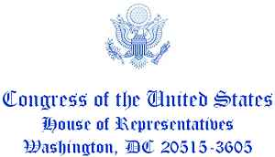

October 5, 2021

Jack Dorsey
Chief Executive Officer
Twitter
355 Market Street, Suite 900
San Francisco, CA 94103

Mr. Dorsey,

We are inquiring about the process your company relies on for the application of “fact-checking” labels. Considering Twitter’s decision last year to begin serving as an arbiter of information, flagging tweets with disputed information, we must conduct oversight on the methodology used in this process.

On September 25, 2021, President Biden posted from his official account “My Build Back Better Agenda costs zero dollars. . . And it adds zero dollars to the national debt.” Plenty of research has been published on how the Build Back Better Agenda will cost an enormous amount of money. The Congressional Budget Office—a nonpartisan entity founded by Congress in 1974—estimates that the infrastructure portion of the Build Back Better Agenda will add $256 billion to deficits from 2021-2031. The Committee for a Responsible Federal Budget (CRFB) reports that the Build Back Better Agenda could cost nearly $4.3 trillion over the next decade. In fact, CRFB reports that “the legislation and budget that passed the Senate would allow for massive new borrowing.”

What evidence does Twitter have supporting the President’s claim? With research and reports indicating that this agenda will cost money, Twitter should have placed a fact-checking label on the President’s tweet. Instead, the tweet still stands, even after the tweet’s claims have been widely refuted.

If Twitter is to continue this practice, it should apply the same standards across all tweets—especially those accounts with a follower base as large as that of the United States President. The company made it a priority to “fact-check” the previous president. Why isn’t the same standard being applied now?

Twitter serves as a disseminator of information to hundreds of million people. It is important that Twitter’s methodology for “fact-checking” content is clear. Without clarity, we can only presume that the company simply fact-checks content that its staff may disagree with politically. Therefore, we demand a briefing before October 23, 2021 on Twitter’s methodology for fact-checking.

We look forward to your response.

God bless,

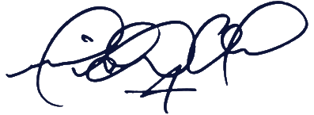
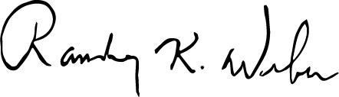

Michael Cloud Randy Weber
Member of Congress Member of Congress

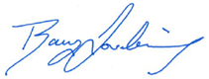

Ralph Norman Barry Loudermilk
Member of Congress Member of Congress

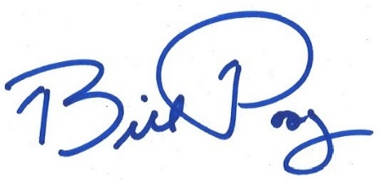
Bill Posey Jody Hice
Member of Congress Member of Congress
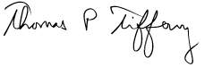
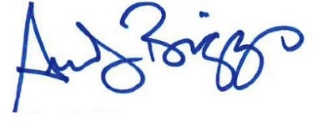

Tom Tiffany Andy Biggs
Member of Congress Member of Congress

President Biden (@POTUS), Sep. 25, 2021, available at https://twitter.com/POTUS/status/1441924106765602819?s=20
Congressional Budget Office, “Senate Amendment 2137 to H.R. 3684, the Infrastructure Investment and Jobs Act, as Proposed on August 1, 2021,” Sept. 29, 2021, https://www.cbo.gov/system/files/2021-08/hr3684_infrastructure.pdf
Committee for a Responsible Federal Budget, “How Much Could the Build Back Better Add to the Debt?,” Aug. 11, 2021, https://www.crfb.org/blogs/how-much-could-build-back-better-add-debt

